Abstract— This article presents an idea for an autonomous robot (figure 1) to assist winegrowers in the tedious task of soil maintenance in vineyards. The robot would help to ensure that the vines have the necessary resources to produce high-quality grapes by maintaining the base of the vines so that the plant can grow in the best conditions.
Vitis, the robot at the service of the vineyard (January 2023)
Chavant Arthur, Demoron Tanguy, Teacher of Polytech Nice Sophia

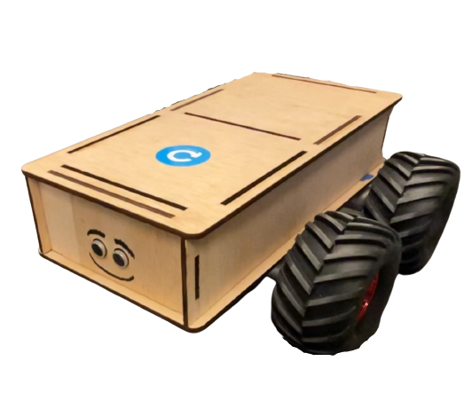
Index Terms — Autonomous robot, Vineyard maintenance, Soil maintenance, Winegrowers, Robotics technology.

Figure 1.

INTRODUCTION
WITH an average of 50h per hectare per year, soil maintenance is a tedious work and requires a lot of time for winegrowers. Our idea is to create an autonomous robot in order to help winegrowers in this task. Soil maintenance is important in a vineyard because the health and fertility of the soil directly affects the growth and productivity of the grapevines. Vines require specific soil conditions, such as proper drainage and adequate nutrients, to thrive. Maintaining the soil through practices such as tilling, fertilization, and irrigation helps to ensure that the vines have the necessary resources to produce high-quality grapes. Additionally, maintaining the soil can also help to prevent erosion, conserve water, and promote biodiversity in the vineyard ecosystem.
There are a few examples of wine robots that are currently available for purchase:
- Naio Technologies: The company sells several robots for vineyard maintenance, including a robot that can be used for thinning, and a robot that can be used for mowing [1].
- Abundant Robotics: This company designs and sells a robotic apple harvester that uses machine vision and machine learning algorithms to identify and pick ripe apples [2].
It's worth noting that these robots tend to be expensive and not yet widely adopted by the industry, they are usually intended for large scale vineyards and research institutions. Also, these technologies are still evolving, so it's worth doing more research to see which specific features and capabilities are offered by each robot, and how well they can perform in different vineyard environments.

TRANSFORMATION OF AN IDEA INTO A MODEL

The sketch
This robot was born from an idea, which we have fleshed out by learnings about the robots that already exist. This work give us a first sketch of what our robot will look like :
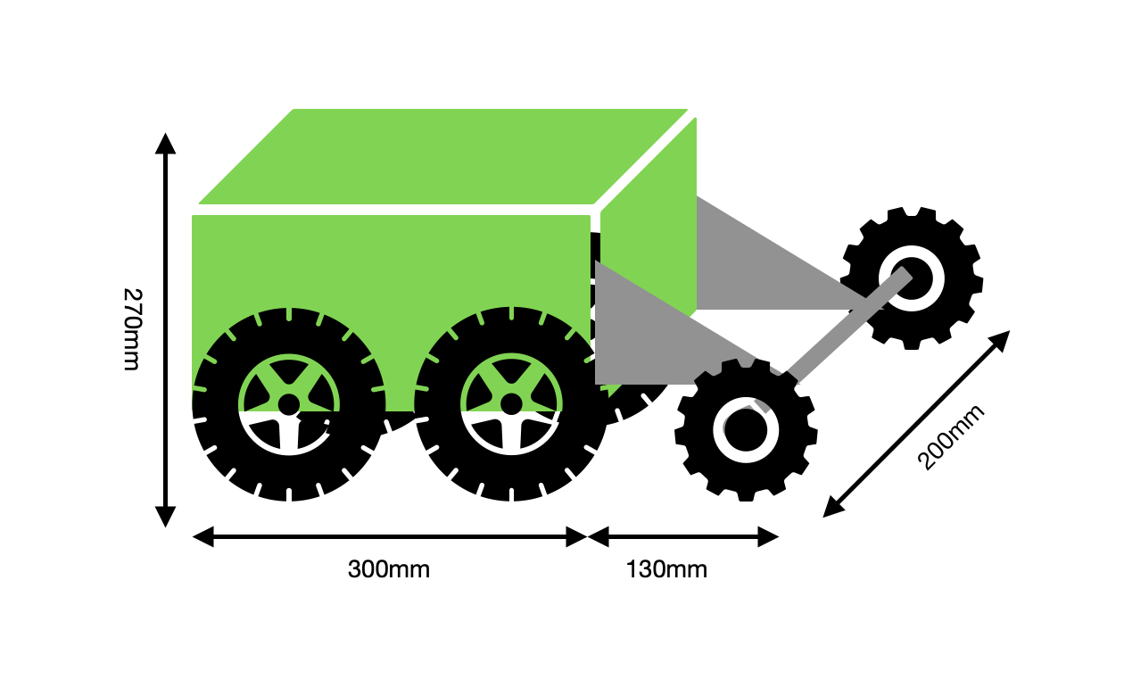

Figure 2.

To make this model there are three main steps, the frame, the wheels and the tools carrier.

Robot body
To begin, we modelled on fusion 360 the different part of the sketch of the robot body then we cut it in wood with the laser printer and put them together in order to have the frame.
An assembled frame allow us to have removable robot and make changes in the future.

Be able to move
Then we need to mechanise this frame. We decided to put four motorized wheels to have a robot adapted to the soil of the vineyard. The engines are put under the frame to raise the frame.
With a weight estimate of the robot we decided to choose four gear motors with a power of 15W and a torque of 1.6 Nm in order to drive on a 20° slope at 4km/h which allows it to adapt to all types of vineyards [3].
The last step was to install the sensors and the Arduino Mega board on the frame to begin code testing.
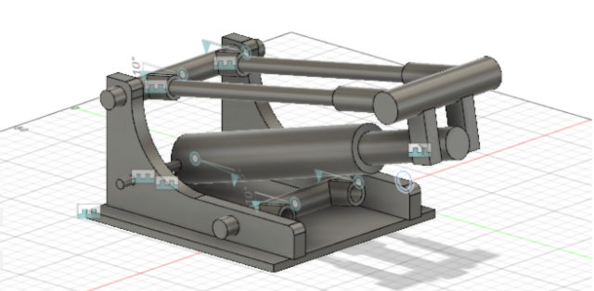

Figure 3.

Vineyard maintenance
Having a robot that moves is good, but a useful robot is better. The last step of this part, and the most difficult ones is to build a toolholder (figure 3) which will allow the robot to maintain the soil of the vines.
The idea is to use an electric cylinder to lower and raise the tool to put it or not in contact with the ground. The translation movement will be transformed into rotation.

MAKE THE MODEL AUTONOMOUS

Moving the Robot
To move in space the robot must be able to move forward, backward and turn. As there is no steering on the wheels, the robot uses the direction of the wheels to turn. For example, to turn left, the two right wheels turn forward and the two left wheels turn backward (figure 4.).
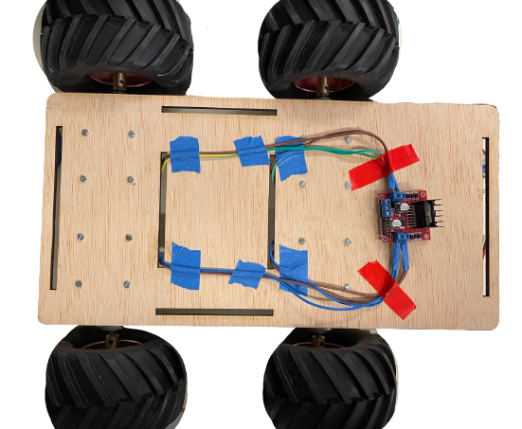

Figure 4.

The advantage of this approach is that the robot does not need any space to make a complete turn, which is very important as there is not always room at the end of the vineyard row [4]. To manage the direction of the motors and ensure that they rotate simultaneously, an H-bridge must be used to control the polarity at the terminals of a dipole.
Note that it is necessary to pay attention to the saturation of the component and choose a bridge adapted to the four motors.

Autonomous movement
For the moment the robot uses two types of sensors, ultrasonic (figure 5.) and infrared (figure 6.).
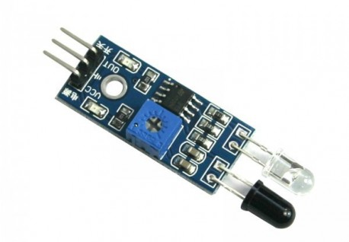
Figure 6.
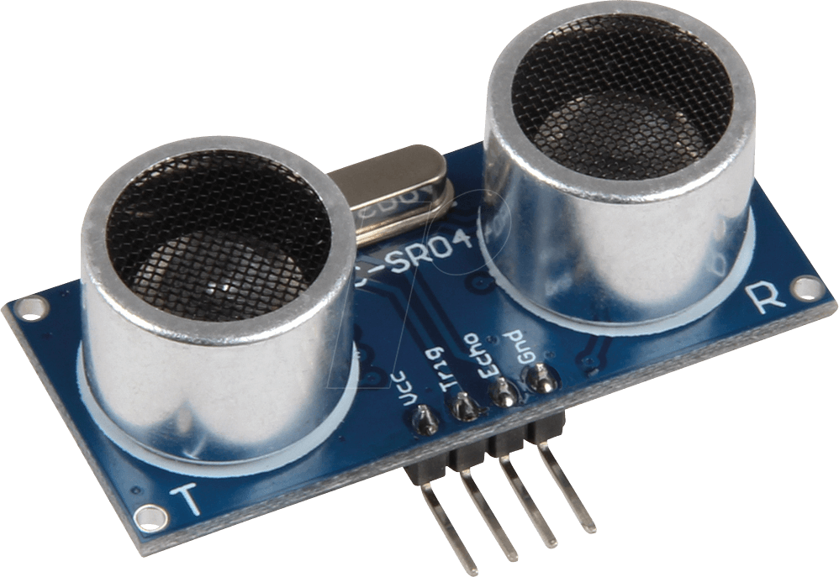

Figure 5.

These sensors have different properties and are not used in the same way [5]. For example, the infrared sensors are placed on the sides and signal the robot to turn or not. They are easy to use because they return a Boolean signal, and they are set in advance according to the triggering distance. The ultrasonic sensor is at the front of the robot and stops the robot in case of obstacles.
It also allows the robot to slow down before the obstacle as it sends the distance in front of it to less than 20 centimeters.

Manual control
Finally, to manually control the robot, the robot is equipped with a Bluetooth remote control (Android smartphone) that allows the user to move the robot wherever he wants (figure 7.).

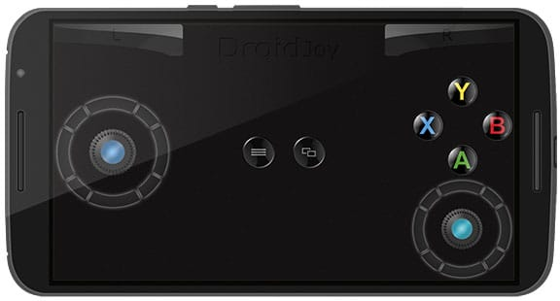

Figure 7.

The Arduino Mega board has 4 brains that communicate with the remote control without using memory for movement and other tasks.

Conclusion
To resume, the article describes an autonomous robot designed to aid winegrowers in soil maintenance tasks in vineyards. The robot has a frame, motorized wheels, and a tool carrier, and is able to navigate tight spaces.
The goal is to improve the health and fertility of the soil for higher quality grape production.
References
- Naïo Technologies, a French start-up company from specialising in agricultural robotics. Available : naio-technologies.com
- Abundant's platform combines computer vision and machine learning to delivery high-quality produce. Available : linkedin.com/company/abundant-robots
- A website to adapt the engines to our needs. Available : community.robotshop.com/blog/show/drive-motor-sizing-tool.
- An article that presents the existing robots and how to be inspired by their solutions. Available: vignevin-occitanie.com/fiches-pratiques/la-robotique-en-viticulture/
- University course on sensors. Available : electronique-mixte.fr/wp-content/uploads/2018/10/Capteur-ultrasonique.pdf

Chavant Arthur, having completed high school in Ardèche, France, went on to do a CPGE in Physics, Chemistry and Engineering in 2020, and is currently studying Robotics at Polytech Nice Sophia as of 2022. Demoron Tanguy, having completed high school in Bourgogne, France, went on to do a CPGE in Physics, Chemistry and Engineering in 2020, and is currently studying Robotics at Polytech Nice Sophia as of 2022.

 Manuscript received January 16, 2023. This work was supported in part by the University Côte d’Azur Polytech Nice Sophia. C. Arthur is with the Robotics Engineering Department, University Côte d’Azur Polytech Nice Sophia, 06410 Biot, France (e-mail: arthur.chavant@etu.univ-cotedazur.fr). D. Tanguy is with the Robotics Engineering Department, University Côte d’Azur Polytech Nice Sophia, 06410 Biot, France (e-mail: tanguy.demoron@etu.univ-cotedazur.fr)

